Episode 127: Capacitors in series and parallel

The derivation of formulae for capacitors in series and parallel will help to reinforce your students’ understanding of circuits involving capacitors.
C₂
C₁
V
C₁
C₂
V
V₁
V₂

Summary
Discussion: Deriving the formulae. (20 minutes)
Worked examples: Using the formulae. (10 minutes)
Student questions: Using the formulae. (30 minutes)
Student experiment: Checking the formulae. (20 minutes)

Discussion:
Deriving the formulae
Your students will have encountered the idea of replacing resistors in series and parallel by a single resistor which has the same effect in the circuit. Remind them of this as an introduction but be ready to dispel any confusion that may arise because the formulae are ‘reversed’ for capacitors.
For capacitors in parallel the pd across each is the same. For capacitors in series, it is the charge stored that is the same.

TAP 127-1: Capacitors in series and parallel formula derivations

Worked examples:
Using the formulae
Choose a couple of simple examples; say, 20 μF and 30 μF in parallel (= 50 μF), and then in series (= 12 μF). Point out that capacitors in parallel combine to give a greater capacitance; in series, the resultant is less than either. What about equal capacitors? (In series, half the capacitance of either.)

Student questions:
Using the formulae
Questions 1 and 2 can reinforce the above discussion. Questions 3 and 4 give practice in using the formulae.

TAP 127-2: Capacitors in series and parallel questions
TAP 127-3: More capacitors in series and parallel questions

Student experiment:
Checking the formulae
If a capacitance meter is available, the results of some of the calculations above can be checked experimentally and/or further combinations can be tried. Provide students with two (or more) capacitors whose values they can measure. They can then connect them together, first in parallel and then in series. Does the meter reading agree with calculated values?

TAP 127- 1: Capacitors in series and parallel formula derivations

Capacitors in parallel
The aim is to find one capacitor, C, to replace C₁ and C₂.
+Q -Q
+Q₂ -Q₂
+Q₁ -Q₁
V
V
C
C₁
C₂

In this case, the pds across the capacitors must be the same so the charge stored on each will be different and we have:

Q₁ = C₁ x V
Q₂ = C₂ x V
and
Q = C x V

For the two circuits to be equivalent,

Q = Q₁ + Q₂
C x V = C₁ x V + C₂ x V

i.e. C = C₁ + C₂

which can be extended to: C = C₁ + C₂ + C₃ + ……

Capacitors in series
Again, the aim is to find a capacitor C which has the same effect as capacitors C₁ and C₂. This means that for the same potential difference V the charge stored must be the same.

+Q -Q
+Q -Q
+Q -Q
V
V
C₁
C₂
C

If either the left hand plate of C₁ or the right hand plate of C₂ held an excess of charge then electrons would move until there was equal charge on the two plates. (Another way to think of this is that the section consisting of the right hand plate of C₁ and the left-hand plate of C₂ is isolated and uncharged.) So:

- the pd across C₁ is V₁ = Q/C₁
- the pd across C₂ is V₂ = Q/C₂
- and the pd across C is V = Q/C

but for components in series:

V = V₁ + V₂
So Q/C = Q/C₁ + Q/C₂

i.e. 1/C = 1/C₁ + 1/C₂

which for more capacitors can be extended to: 1/C = 1/C₁ + 1/C₂ + 1/C₃ ……

TAP 127- 2: Capacitors in series and parallel questions

The diagram below shows three capacitors of capacitance C₁, C₂ and C₃ connected in parallel to a potential difference V. Work through question 1 in order to obtain the value, in terms of C₁, C₂ and C₃, of a single capacitor C that would replace all three.

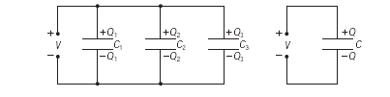
Question
1. (a) Write down expressions for the following:
(i) C₁ in terms of V and Q₁
(ii) C₂ in terms of V and Q₂
(iii) C₃ in terms of V and Q
(iv) C in terms of V and Q₃
(b) What is the total charge Q of all three capacitors in terms of Q₁, Q₂ and Q₃?
(c) Using your answers to (a) and (b), obtain an expression for C in terms of C₁, C₂ and C₃.

Capacitors in series
Three capacitors C₁, C₂ and C₃ connected in series are shown below. A potential difference V is applied across all three.
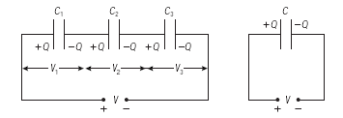
Work through question 2 in order to obtain the value, in terms of C₁, C₂ and C₃, of a single capacitor C that would replace all three.

2. (a) The diagram above shows that each capacitor has an identical charge.
Explain how this comes about.
(b) Write down expressions for the following
(i) V₁ in terms of Q and C₁
(ii) V₂ in terms of Q and C₂
(iii) V₃ in terms of Q and C₃
(iv) V in terms of Q and C
(c) What is the total potential difference V across all three capacitors in terms of V₁, V₂ and V₃?
(d) Using your answers to (b) and (c), obtain an expression for C in terms of C₁, C₂ and C₃.

You should have noticed that the expressions for capacitors joined in series and parallel are ‘the other way round’ to the expressions for resistors. Resistors in series are simply added together; for capacitors in series you need to add reciprocals and find the reciprocal of the result. Capacitors in parallel add together, whereas for resistors in parallel it is the reciprocals that must be added.

3. What is the combined capacitance of a 10 μF capacitor, a 20 μF capacitor and a 30 μF capacitor connected (a) in parallel (b) in series?

4. What is the combined capacitance of a 10 μF capacitor and a 20 μF capacitor connected in parallel, and then connected in series to a 30 μF capacitor as shown below.
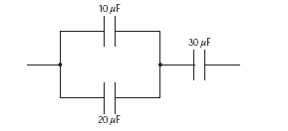

Answers and worked solutions
1.
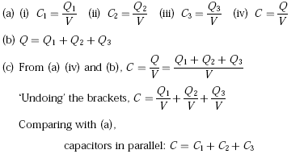
2. (a) Charge cannot be created or destroyed (it is conserved), so it can only be redistributed between capacitors. The charges have to be produced within the plates and connecting wires so, when a positive charge is produced on one plate, the one next to it will be made negative. This positively charged plate will attract the electrons from the adjacent plate and connectors, so making the one next to it negatively charged and the plate next to that positively charged. The effect of that positively charged plate is the same on its neighbour, and so on.
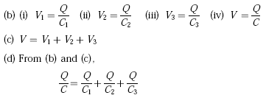
3. (a) From the equation derived in question 1:
(b) From the equation derived in question 2:
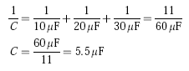
4. Taking the two in parallel first, we have
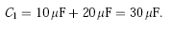
Combining this with the other capacitor in series, we have
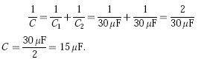

External references
This activity is taken from Salters Horners Advanced Physics, Medium is the Message, Activity 22, Additional Sheet 3

TAP 127- 3: More capacitors in series and parallel questions

1. Calculate the total capacitance of each of the following arrangements of capacitors:
(a) two capacitors of 100 μF connected in series
(b) two capacitors of 100 μF connected in parallel
(c) two capacitors, one of 100 μF and the other of 200 μF connected in series
(d) two capacitors, one of 100 μF and the other of 200 μF connected in parallel
(e) two capacitors, one of 100 μF and the other of 4700 μF connected in parallel with the combination connected in series with another capacitor of capacitance 4700 μF

2. If you have several 2.0 μF capacitors each capable of withstanding 240V without breakdown how would you assemble a combination having an equivalent capacitance of:
(a) 0.40 μF
(b) 1.2 μF,
each capable of withstanding 1000V?

Answers and worked solutions
1
(a) 50 μF
(b) 200 μF
(c) 67 μF
(d) 300 μF
(e) 2400 μF (2375 μF)

2
(a) Five capacitors in series
(b) Three parallel sets of five capacitors in series
(both can tolerate 5 × 240V = 1200V)

External references
This activity is taken from Resourceful Physics http://resourcefulphysics.org/

